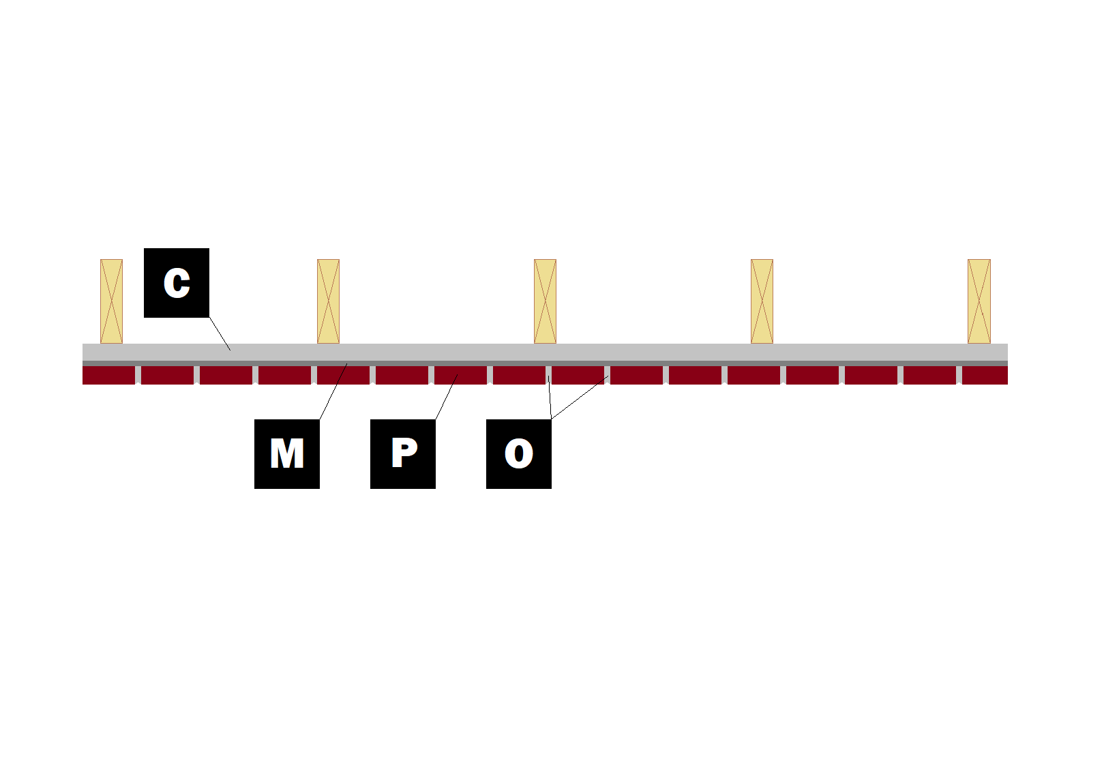

Assembly I-8
Ceiling Application
C – Cement Board
M – Old Mill Brick & Panel Adhesive or Stone Adhesive
P – Finish (Thin Brick, Stone, Tile or Manufactured Stone)
O – Old Mill Colored Pointing Mortar

