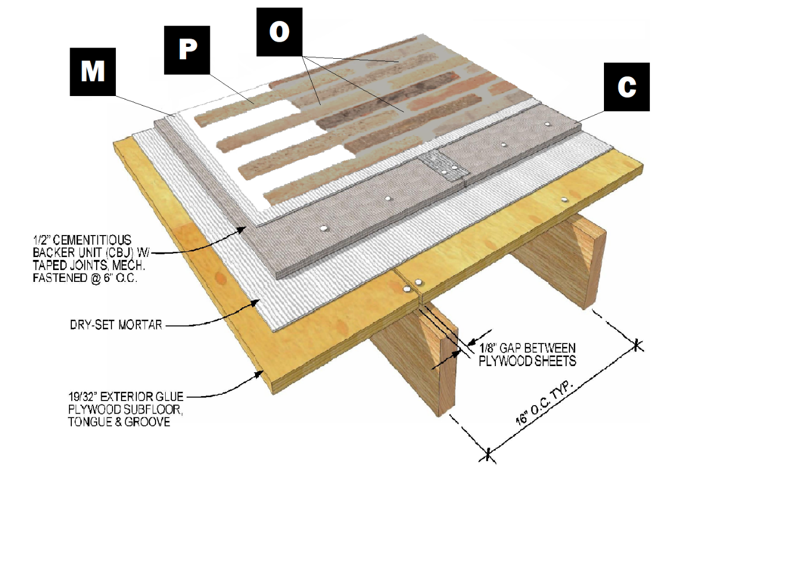

Assembly I-7
Wood Subfloor with Cement Board
C – Cement Board
M – Old Mill Brick & Panel Adhesive or Stone Adhesive
P – Finish (Thin Brick, Stone, Tile or Manufactured Stone)
O – Old Mill Colored Pointing Mortar

