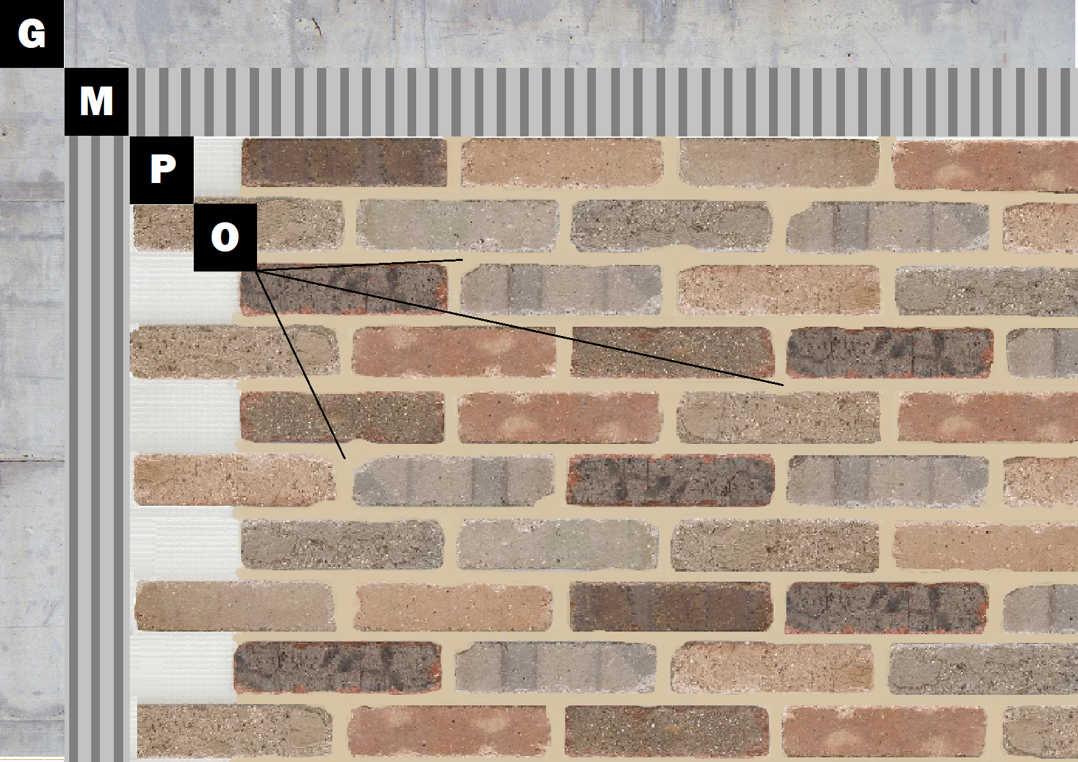

Assembly I-6
Concrete, Plaster, Stucco or EIFS
G – Concrete, Plaster, Stucco or EIFS
M – Old Mill Brick & Panel Adhesive or Stone Adhesive
P – Finish (Thin Brick, Stone, Tile or Manufactured Stone)
O – Old Mill Colored Pointing Mortar

