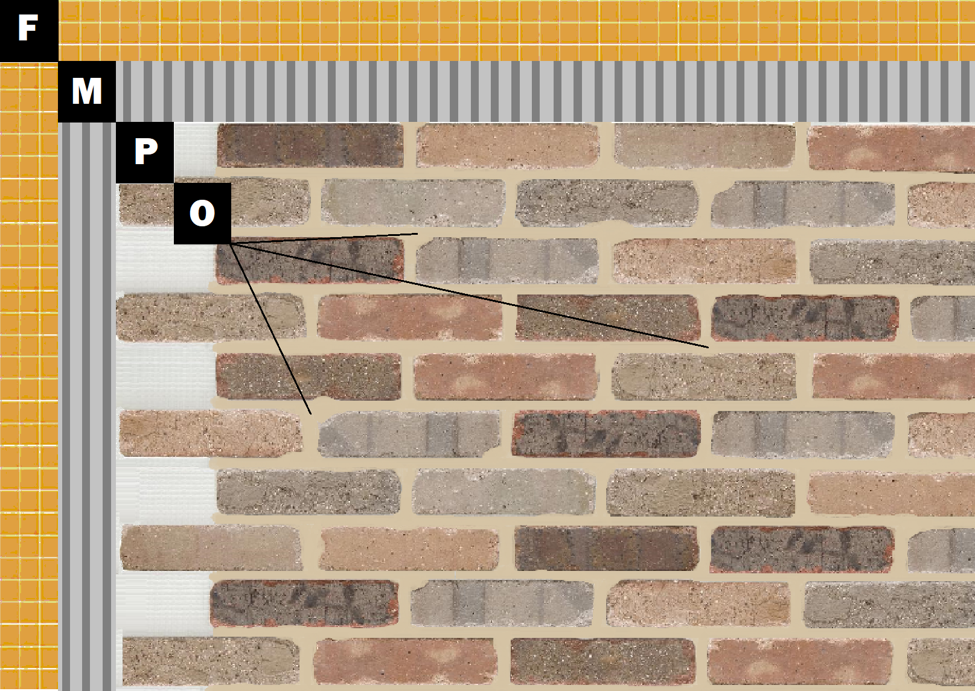

Assembly I-5
Existing Tile or Stone
F – Existing Tile or Stone
M – Old Mill Brick & Panel Adhesive or Stone Adhesive
P – Finish (Thin Brick, Stone, Tile or Manufactured Stone)
O – Old Mill Colored Pointing Mortar

