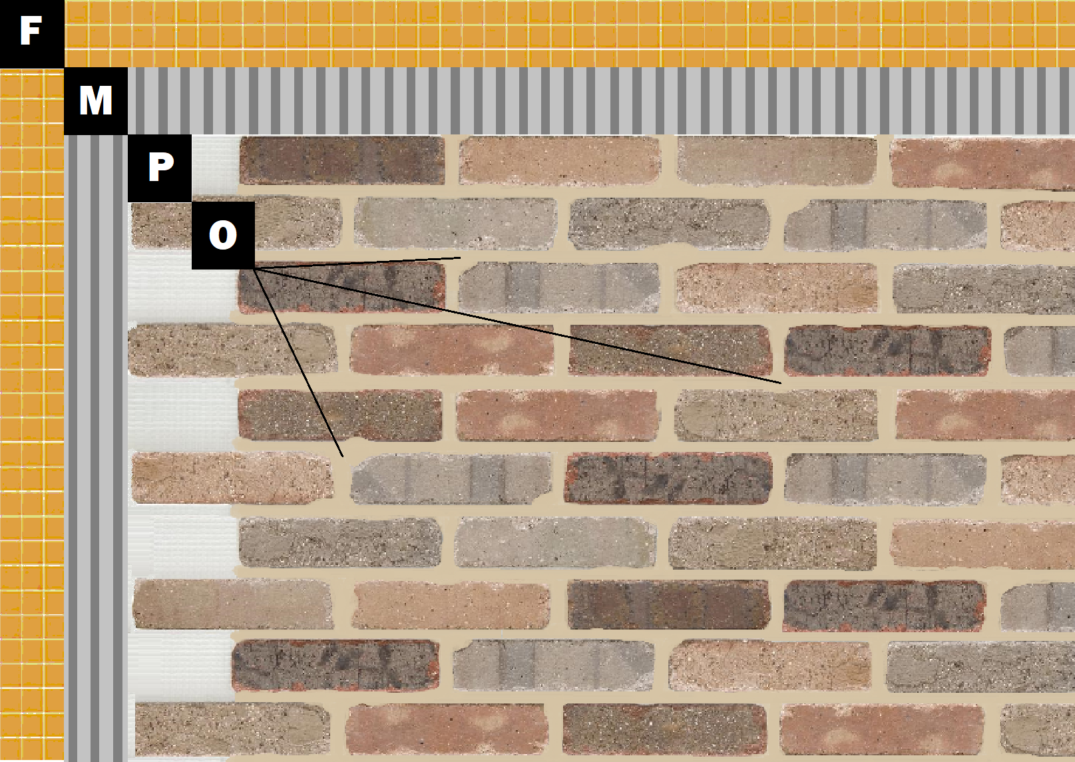

**Assembly I-5**

**Existing Tile or Stone**

F – Existing Tile or Stone

M – Old Mill Brick & Panel Adhesive or Stone Adhesive

P – Finish (Thin Brick, Stone, Tile or Manufactured Stone)

O – Old Mill Colored Pointing Mortar