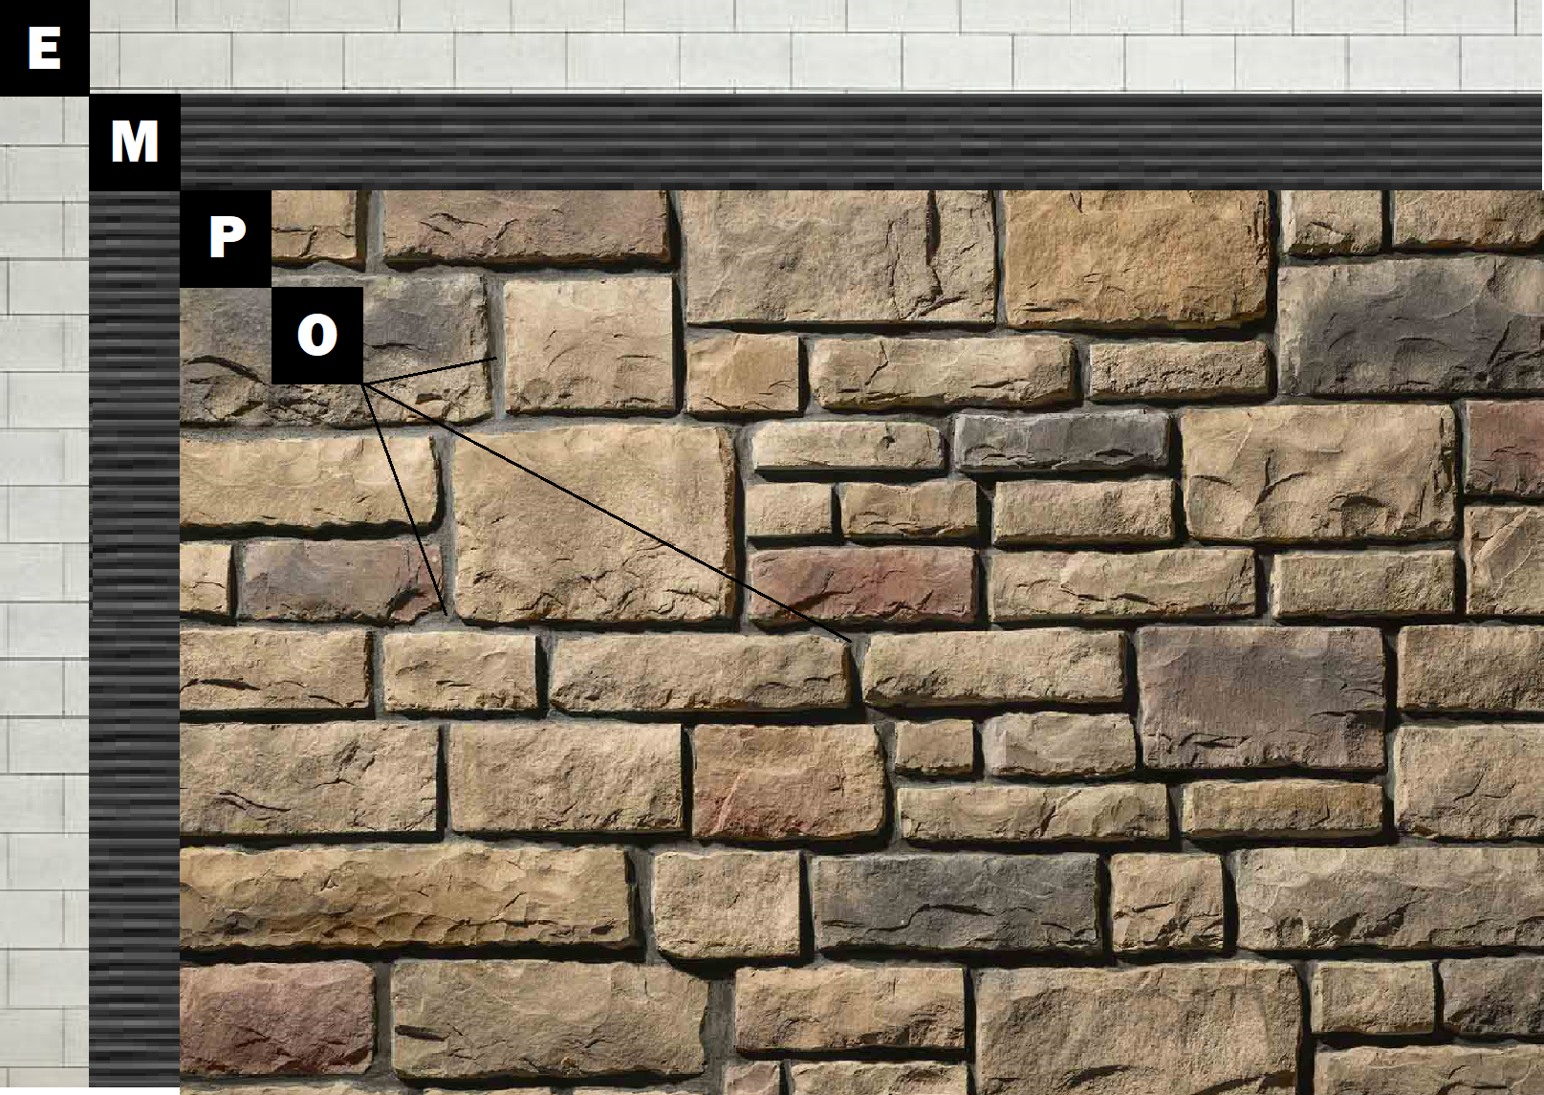

Assembly I-4
Brick or CMU
E – Brick or CMU
M – Old Mill Brick & Panel Adhesive or Stone Adhesive
P – Finish (Thin Brick, Stone, Tile or Manufactured Stone)
O – Old Mill Colored Pointing Mortar

