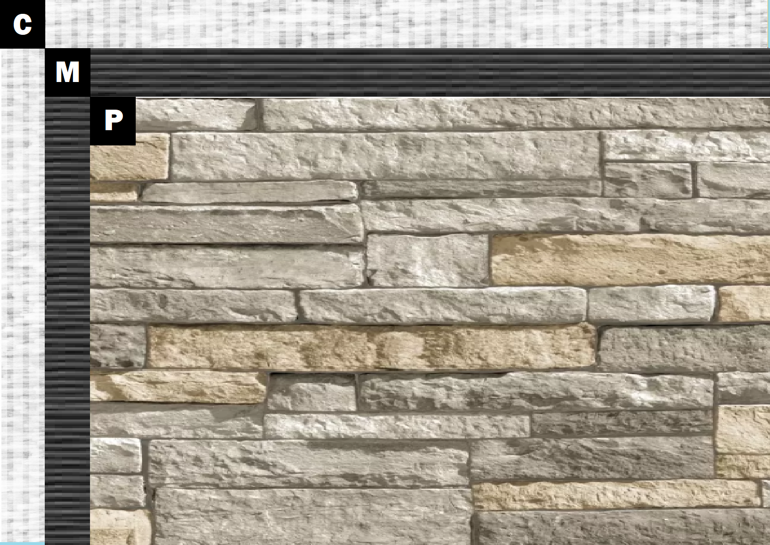

Assembly I-3
Cement Board
A – Cement Board
N – Old Mill Brick & Panel Adhesive or Stone Adhesive
P – Finish (Thin Brick, Stone, Tile or Manufactured Stone)

