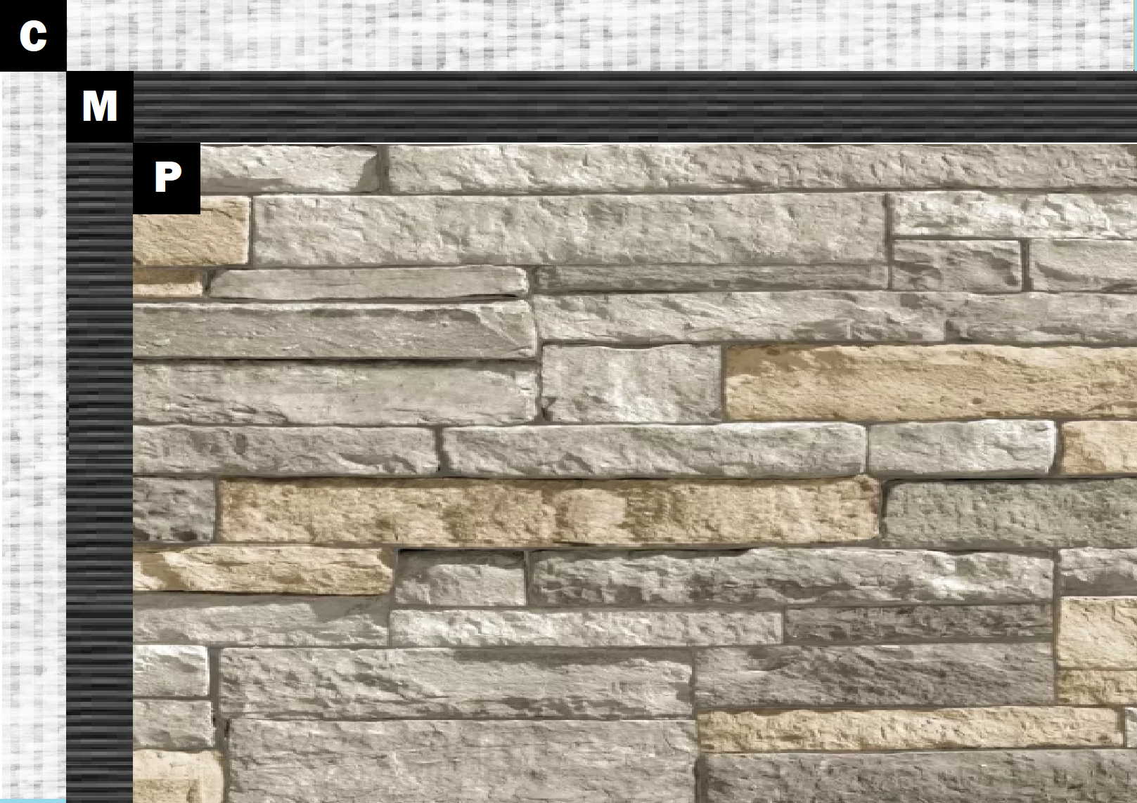

**Assembly I-3**

**Cement Board**

A – Cement Board

N – Old Mill Brick & Panel Adhesive or Stone Adhesive

P – Finish (Thin Brick, Stone, Tile or Manufactured Stone)