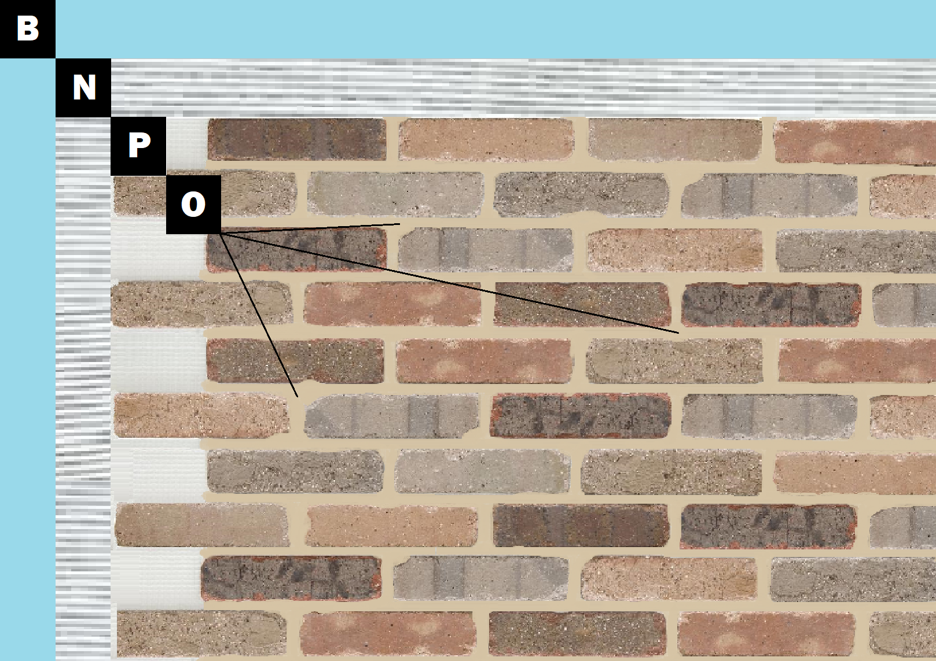

Assembly I-2
Painted Drywall
A – Painted Drywall
N – Old Mill Mastic
P – Finish (Thin Brick, Stone, Tile or Manufactured Stone)
O – Old Mill Colored Pointing Mortar or Type S Masonry Mortar

