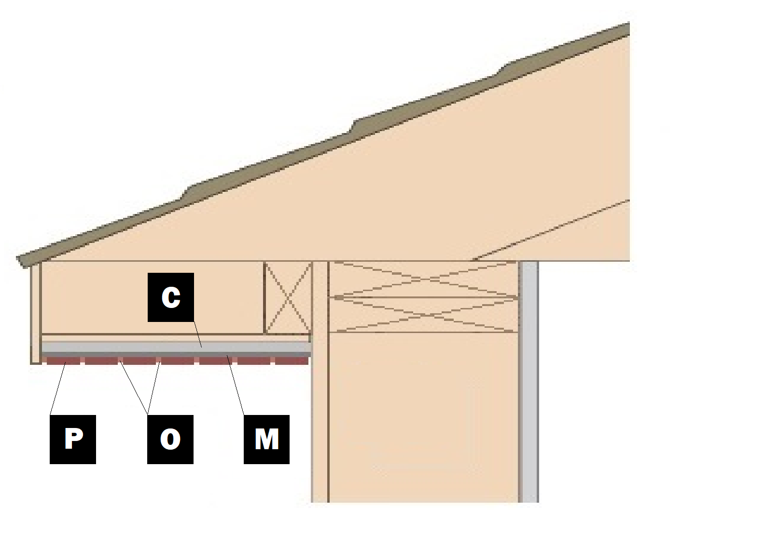

Assembly E-8
Soffit Installation
C – Cement Board
M – Old Mill Brick & Panel Adhesive or Stone Adhesive
P – Finish (Thin Brick, Stone, Tile or Manufactured Stone)
O – Old Mill Colored Pointing Mortar or Type S Masonry Mortar

