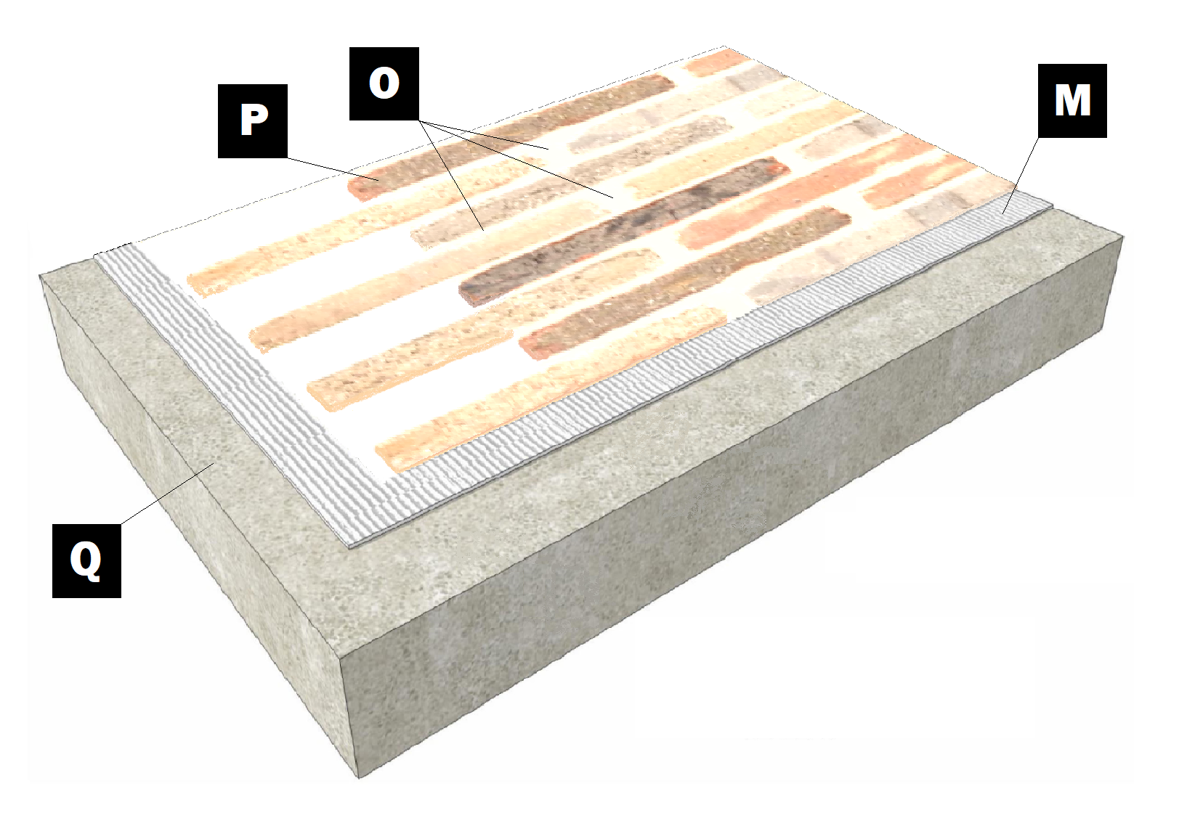

Assembly E-7
Concrete Slab
Q – Concrete Slab
M – Old Mill Brick & Panel Adhesive or Stone Adhesive
P – Finish (Thin Brick, Stone, Tile or Manufactured Stone)
O – Old Mill Colored Pointing Mortar or Type S Masonry Mortar

