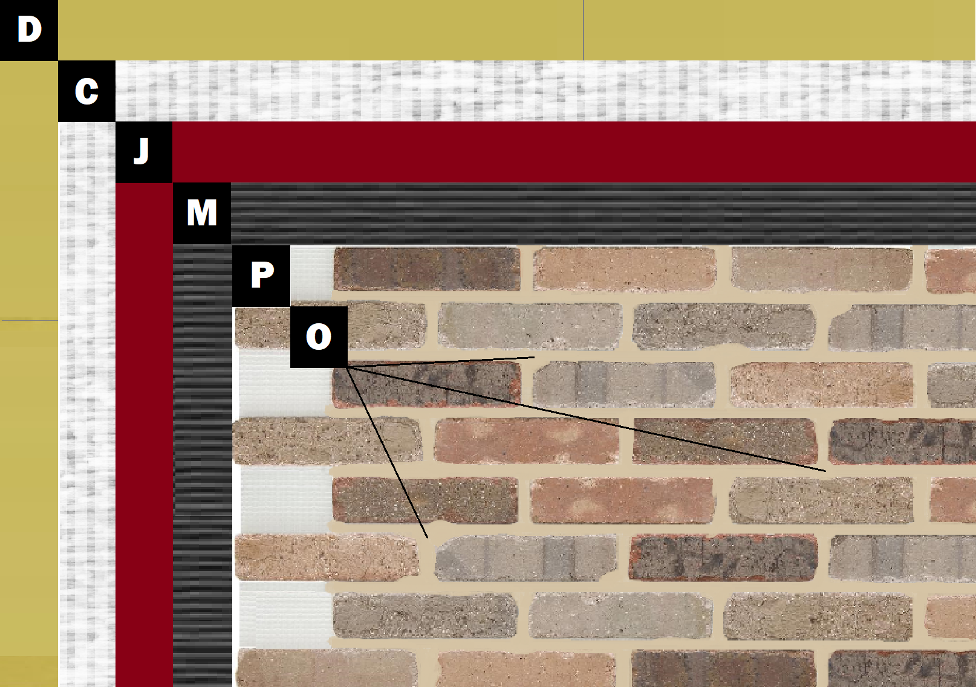

Assembly E-6
Cement Board over Sheathing
D – Sheathing
C – Cement Board (Tape & Float Joints per Manufacturer)
J – Old Mill Air & Water Barrier
M – Old Mill Brick & Panel Adhesive or Stone Adhesive
P – Finish (Thin Brick, Stone, Tile or Manufactured Stone)
O – Old Mill Colored Pointing Mortar or Type S Masonry Mortar

