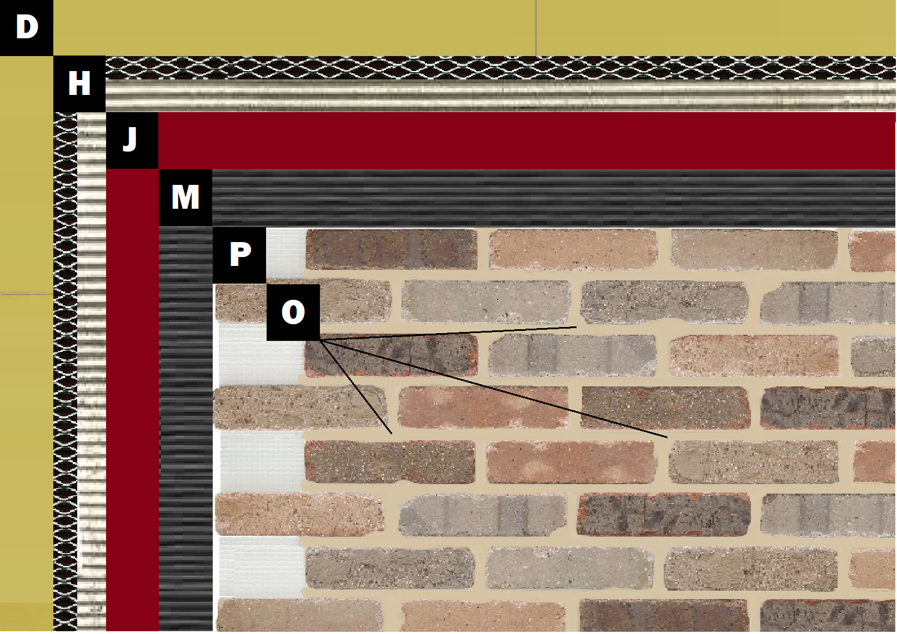

Assembly E-5
Lath and Scratch over Sheathing
D – Sheathing
H – Traditional Lath and Scratch Substrate
J – Old Mill Air & Water Barrier
M – Old Mill Brick & Panel Adhesive or Stone Adhesive
P – Finish (Thin Brick, Stone, Tile or Manufactured Stone)
O – Old Mill Colored Pointing Mortar or Type S Masonry Mortar

