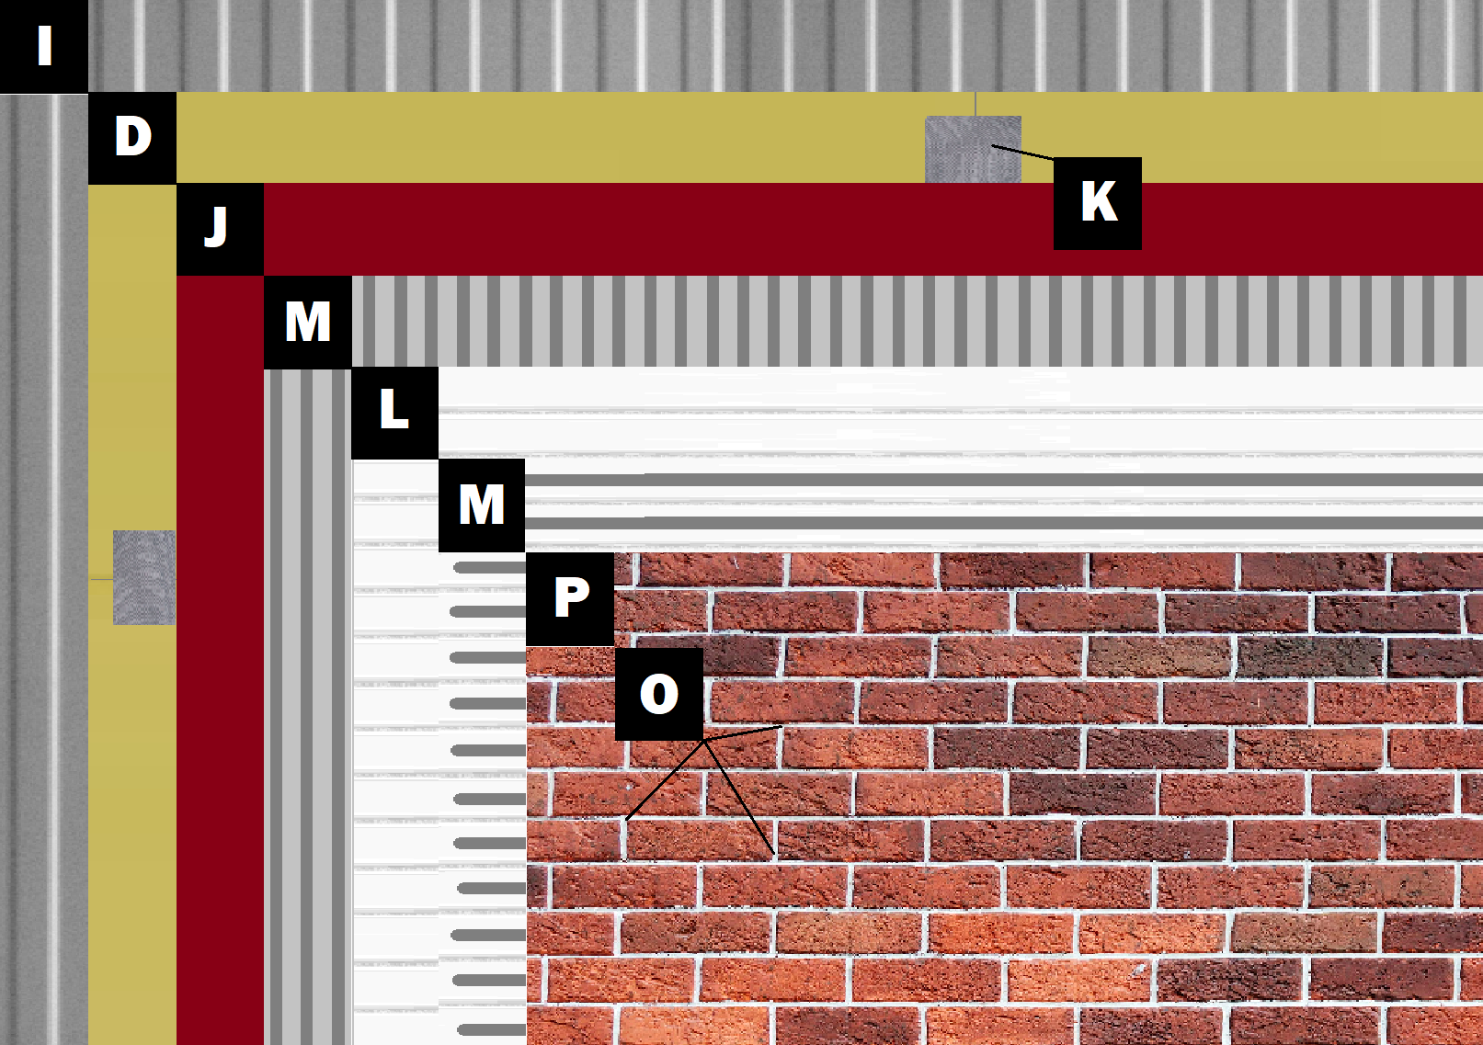

Assembly E-4
Panel+ over Metal Building
D – Sheathing or Cement Board
J – Old Mill Air & Water Barrier
M – Old Mill Brick & Panel Adhesive or Stone Adhesive
L – Old Mill EPS Foam Panel
P – Finish (Thin Brick, Stone, Tile or Manufactured Stone)
O – Old Mill Colored Pointing Mortar or Type S Masonry Mortar

