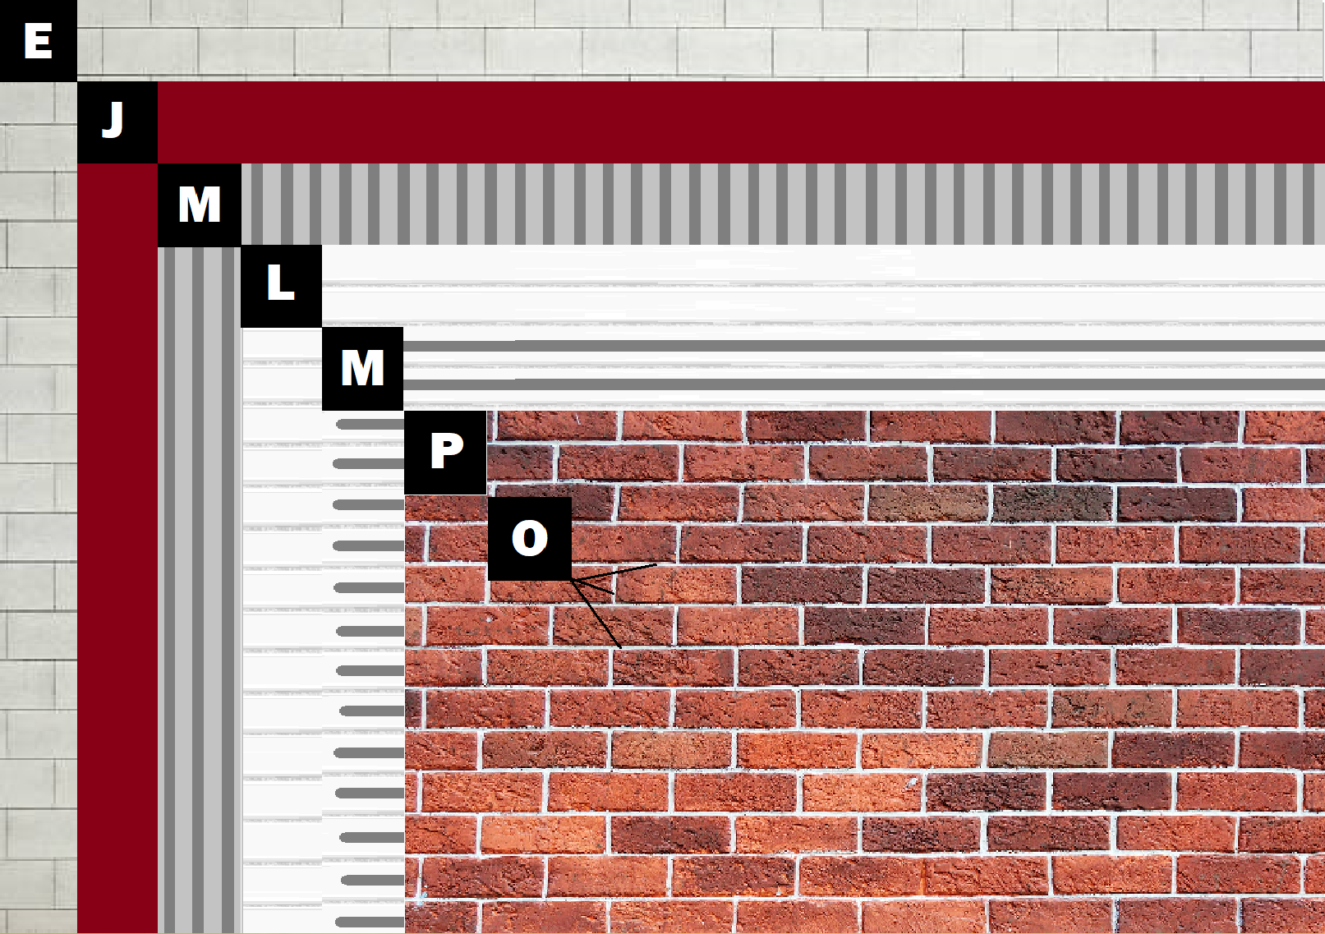

Assembly E-2
Panel+ over Brick or CMU Wall
D – Brick or CMU
J – Old Mill Air & Water Barrier
M – Old Mill Brick & Panel Adhesive or Stone Adhesive
L – Old Mill EPS Foam Panel
P – Finish (Thin Brick, Stone, Tile or Manufactured Stone)
O – Old Mill Colored Pointing Mortar or Type S Masonry Mortar

