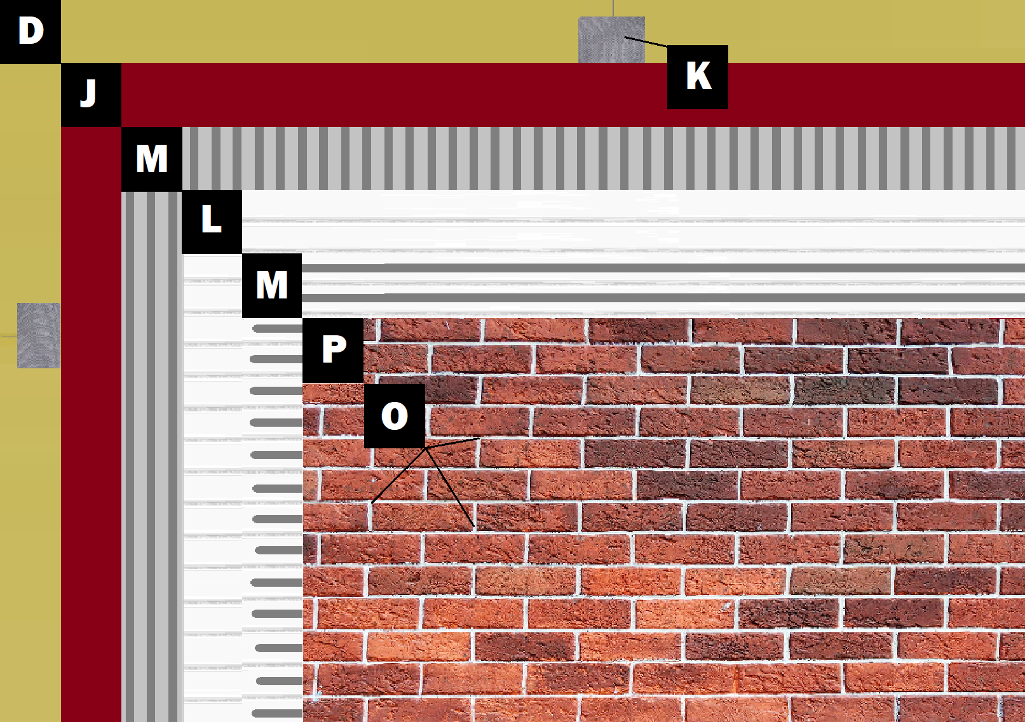

Assembly E-1
Panel+ over Framing/Sheathing
D – Sheathing (Exterior Gypsum, OSB, Plywood)
K – Old Mill Polylaminate Reinforcing Fabric
J – Old Mill Air & Water Barrier
M – Old Mill Brick & Panel Adhesive or Stone Adhesive
L – Old Mill EPS Foam Panel
P – Finish (Thin Brick, Stone, Tile or Manufactured Stone)
O – Old Mill Colored Pointing Mortar or Type S Masonry Mortar

